SMARTIE – Secure and Smarter Cities Data Management
Dissertation Progress Report
Vedran Semenski

I. Current state
In the current state of my work I have integrated the Cassandra and Redis databases for storing sensor data and policies. For this I have built Data Managers that handle all the setup, configuring and communication with the database. They control the database over Java clients found ever the official websites for Cassandra and Redis. The Databases are currently filled with dummy test data for later use.
The data structure used for storing policies in Redis is a list of key-values with auto incrementing ids. All the policies can be fetched at once if needed.
The data structure used for storing sensor data in Cassandra is currently one table with the following values: sensor_id, type, value double, location and datetime. The access control part of the work is at the initial phases. I have been exploring an GitHub project that could provide me with a lot of the functionality but because it has almost no documentation progress has been slow.
Regarding the written part of the dissertation the SotA is written and I will deliver the first version of the document by the end of this week (22.3.2015.) after I make some corrections.

II. Solution architecture
The current proposed architecture of the solution can be seen on the image diagram below. This solution is a slight modification to the architecture that can be seen in the OASIS XACML proposal. The context handles is a central entity that handles all the logistics and contains the main high-level workflow. The Request processing module is a module for parsing raw user created request and turning them into well defined XAML requests. Other modules don't need explanation.

II. Next steps (development plan)
- Building a prototype PEP working with test request
- Build a PRP that fetches policies from Redis over the Policy Storage manager
- Build a test PIP that fetches attribute information/values
- Finding and integrating a PDP. Hopefully a solution that already exists and not building one from zero.
- Build a Context Handler that connects all of the other parts
- Build a PAP with a simple GUI
- Initial Testing and Refactoring
- Improving the solution - removing test functionalities and replacing them with real ones
- Main Testing and Refactoring - Test scenarios
- Making modifications for integrating into SmartData
- Testing in Smart Data
- Finalizing
Along all of these steps the plan is to continuously write and build the written part of the dissertation and giving periodical reports and meeting along the way.

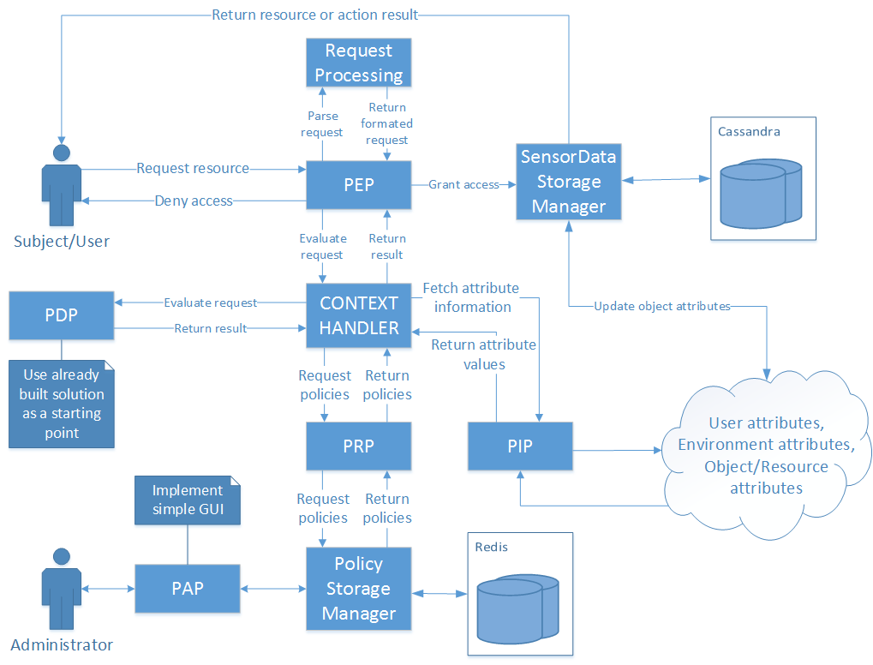
General solution architecture

